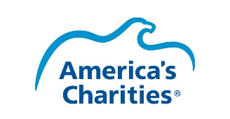
Snapshot 2017 Promotion Toolkit
Hashtag to use with all messages: #Snapshot2017

What’s In This Guide?
- Social media messages and graphics
- Content to share with your donors via email and/or on your website
- Information for you to share with corporate partners or board directors
The URLs listed in this guide are for general use. If your organization would like to receive a full dataset of responses from your donors at the conclusion of the survey, please contact America’s Charities’ VP, Marketing and Communication, Lindsay Nichols at lnichols@charities.org and request a unique survey URL for your team to use.

Social Media Messages:
Tip: The URL provided in these messages directs donors to the Snapshot 2017 survey. If you would like to give donors more context around how taking this survey will help your nonprofit, we suggest placing the web content provided in this document on your website, include the survey link below on that page and replacing the social media link with a URL that directs them to your website landing page.
Message: | Graphic to Use:
Do you support [insert charity handle] via your employer’s giving program? Pls take #Snapshot2017 survey to help us http://impact.ac/2lopd9D | 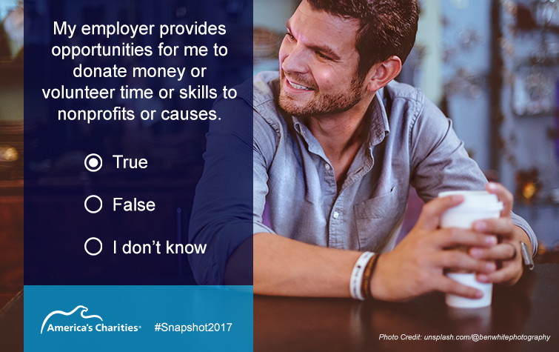
Matching gifts = incredible way to support [insert your handle] & so is taking this #Snapshot2017 survey: http://impact.ac/2lopd9D | 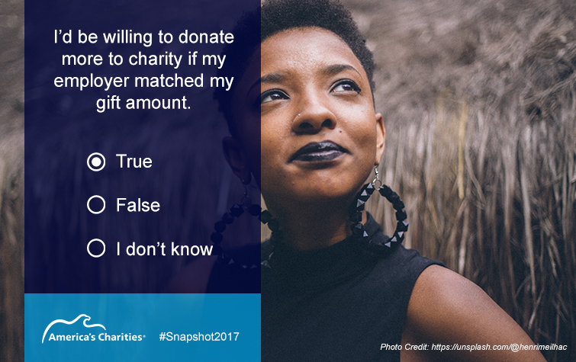
Want to help increase [insert your handle]’s capacity & impact? Please take this #Snapshot2017 @AmerCharities survey http://impact.ac/2lopd9D | 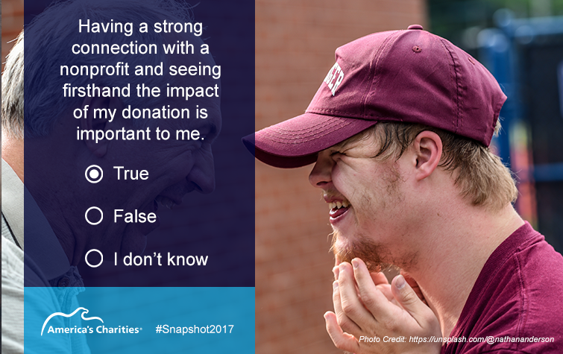
Your feedback on giving & volunteering needed! Pls help [insert your handle] by taking #Snapshot2017 survey http://impact.ac/2lopd9D | 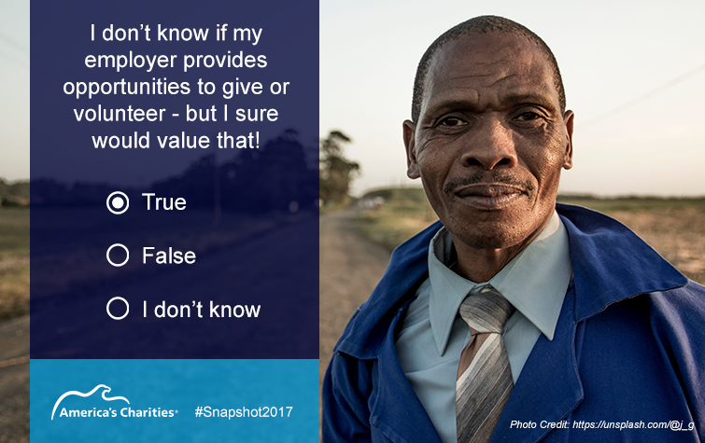
Pro bono & skills volunteers matter to [insert your handle] & you can help us by taking #Snapshot2017 survey http://impact.ac/2lopd9D | 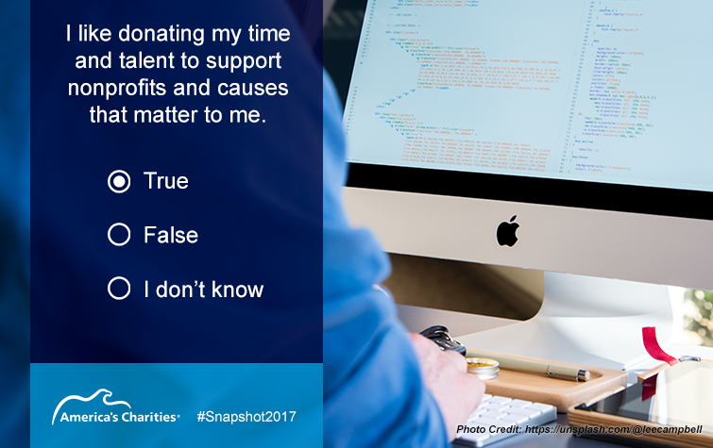

Content for Your Website and/or Donor Email Communications:
Subject/Title: How 10 Minutes of Your Time Can Amplify [charity name]’s Impact
This past year, your support empowered [charity name] to:
- [insert a bullet point on the impact you made thanks to donor financial and/or volunteer support].
- [insert a bullet point on the impact you made thanks to donor financial and/or volunteer support].
- [insert a bullet point on the impact you made thanks to donor financial and/or volunteer support].

And we’re already off to a great start to 2017 thanks to the support that continues rolling in from incredible people like you who are passionate about the impact our organization has on [state the audience your work supports].

We know the best way to demonstrate our appreciation for you is to continue delivering greater impact each year, but we also want to make sure we are supporting you by presenting information and opportunities based on your giving preferences.

By taking the following survey, which consists of 10 multiple choice questions and will take 10-15 minutes of your time max, [charity name] will be able to do a better job of meeting your expectations, while also better understanding new ways we can strengthen our organization’s results – thereby helping even more [state the audience your work supports].

Visit http://impact.ac/2lopd9D to take the survey and then please share the following message with your friends on social media to help us do a better job meeting their expectations.

Sample message for donor to share:
Please join me in increasing [insert your handle]’s capacity & impact! Take this 10-question #Snapshot2017 survey http://impact.ac/2lopd9D

Thank you for your support!
Sincerely,
[sender’s name, title]

Information to Share with Your Corporate Partners and/or Board Directors

Subject: Opportunity to Benefit Your Company and [charity name]

Your support of [charity name] as a [corporate partner/board director] is greatly valued. To show our appreciation, we would like to extend a unique opportunity to benefit your company, which will in turn also support [charity name]’s continued success.

America’s Charities, which inspires employees and organizations to support causes they care about to bring more resources to the nonprofits that are changing our world, has a free tool - Snapshot 2017 - which will help your company better understand its employees’ giving preferences.

For years, America’s Charities has reported trends, attitudes and perceptions in employee workplace giving through their Snapshot Report Series. So far, they have explored trends from the perspective of:
- Employers: Snapshot 2015 and Snapshot 2013
- Nonprofits: Snapshot 2014

Now, with Snapshot 2017, they are offering a first-ever look at trends in employee giving from the perspective of donors. [charity name] is using Snapshot 2017 as a donor listening tool to use for our donor cultivation and donor retention practices. Similarly, your company can use it as an employee listening tool to gain insights on:
- Whether you are meeting your employees’ expectations through employee giving, volunteering, and other corporate philanthropy initiatives,
- How important various giving opportunities are in determining where employees choose to work,
- What inspires employees to give time, talent and/or money,
- Components of a positive employee giving experience,
- How employees prefer to support nonprofits and causes like ours, and
- What causes employees are most passionate about supporting
Right now, with help from organizations like ours and yours, America’s Charities’ researchers are surveying donors with the Snapshot 2017 survey. Your company can participate and benefit by distributing the Snapshot 2017 survey to your employees. Employee responses will be confidential and anonymous in the Snapshot 2017 Report, which will be shared this fall.
What makes this opportunity really unique?
If you contact America’s Charities’ VP, Marketing and Communication, Lindsay Nichols at lnichols@charities.org, she will provide you with a unique survey URL to share with your employees and can answer any questions you have about Snapshot 2017. At the conclusion of the survey, your company will be sent the full dataset of responses from your employees. That way, you’ll be able to assess your employees’ values and giving preferences. And once the Snapshot 2017 report is published this fall, you’ll be able to analyze and benchmark your employees’ responses against the larger field’s response.
You can learn more about Snapshot 2017 by visiting www.charities.org/snapshot2017 or by contacting Lindsay Nichols at lnichols@charities.org or 703.674.5359.
I hope your company can take advantage of this opportunity. Thank you again for all your support!
Sincerely,
[sender’s name, title, nonprofit name]

